**Research Proposal**

Design and Creative Technologies

Torrens University, Australia

**Student:** Luis Guilherme de Barros Andrade Faria - A00187785

**Subject Code:** REM 502

**Subject Name:** Research Methodologies

**Assessment No.:** 3

**Title of Assessment:** Research Proposal

**Lecturer:** Dr. Bushra Naeem

**Date:** Dec 2025

Copyright © 2025 by Luis G B A Faria

Permission is hereby granted to make and distribute verbatim copies of this document provided the copyright notice and this permission notice are preserved on all copies.

**Table of Contents**

**1.** **Abstract** 3

**2.** **Introduction** 4

**3.** **Literature Review** 6

3.1. Patient Experience as a Business Driver 6

3.2. The Net Promoter Score Debate 7

3.3. AI-Enabled Sentiment Analysis 7

3.4. Emotions and Customer Engagement 8

3.5. Identified Knowledge Gap and Research Contribution 10

**4.** **Methodology and Methods** 11

4.1. Research Design and Philosophical Orientation 11

4.2. Data Sources and Sampling 12

4.3. Data Preparation 13

4.4. Analytical Procedures 14

4.5. Ethical Considerations 15

4.6. Reliability, Validity and Limitations 16

4.7. Software Design Flow (ICT Framework Overview) 17

**5.** **Conclusion** 17

5.1. Expected Contributions and Implications 18

**6.** **Proposed Timeline** 20

**7.** **Appendices** 23

7.1. Appendix A – Company Consent Letter 23

7.2. Appendix B – Data Preparation Code Excerpt 24

7.3. Appendix C – Ethics Statement 24

**8.** **References** 27

Exploring the Relationship between Net Promoter Score and Revenue Growth in Healthcare Clinics

# **Abstract**

This study will investigate whether the Net Promoter Score (NPS) is statistically correlated with revenue growth in healthcare clinics. While NPS is widely used as a measure of patient satisfaction and loyalty, limited empirical research validates its direct financial impact in the healthcare context. Adopting a quantitative correlational design within a pragmatic-positivist paradigm, this research will analyze a three-year dataset (2022–2025) from Pro-Corpo Estética, a network of Brazilian clinics. Monthly NPS and revenue data will be examined using descriptive statistics, Pearson correlation, and linear regression to determine the strength and direction of their relationship.

By establishing empirical evidence on how patient experience metrics align with business outcomes, the research will contribute actionable insights for healthcare managers. The project also aligns with Torrens University’s "Here for Good" ethos, promoting responsible data-driven innovation that supports both patient care quality and sustainable business performance. Findings will validate NPS as cost-effective or justify AI-enhanced sentiment analysis investment, providing empirical evidence to optimize patient experience measurement and ensure sustainable clinic operations.

# **Introduction**

In an era where healthcare organizations face increasing pressure to balance patient-centred care with financial sustainability, analytics will play a crucial role in revealing relationships between experience metrics and operational outcomes (Press Ganey, 2023). The Net Promoter Score (NPS), a single-question measure of recommendation likelihood (Reichheld, 2003), is widely used as a proxy for loyalty. Yet in clinical settings, its connection to measurable business outcomes such as revenue growth remains underexplored, often overshadowed by qualitative interpretation or anecdotal evidence. Recent studies highlight the potential of NPS when paired with information-system support to strengthen retention strategies (Cahya et al., 2025), reinforcing the need for empirical validation in healthcare.

This evidence gap restricts data-driven decision-making, particularly for AI-enabled systems expected to automate NPS monitoring and predict financial performance. Establishing this relationship will guide targeted managerial strategies aimed at improving retention and referral behaviors, contributing to sustainable clinic growth.

*Figure 1 – The gap between NPS adoption and empirical validation in healthcare settings. This study will bridge operational metrics with financial performance measurement.*

This project will develop an ICT-driven framework using data-analytics and business-intelligence techniques to examine whether NPS trends align with clinic-level revenue performance. It will address two core research questions: (1) To what extent is NPS correlated with revenue growth in healthcare clinics? and (2) What is the direction and strength of this relationship? The study will test the hypothesis that NPS is positively and significantly correlated with revenue growth (r > 0.3, p < 0.05). The project aligns with Torrens University’s Here for Good ethos by promoting responsible, data-driven innovation that enhances patient well-being while supporting sustainable healthcare practices.

# **Literature Review**

# Patient Experience as a Business Driver

Across service industries, patient or customer experience has become a measurable business asset. Godovykh and Pizam (2023) emphasize that in healthcare, experience extends beyond satisfaction, it encompasses emotional safety, empathy, and trust. Positive encounters build loyalty, which in turn drives repeat visits and referrals, translating indirectly into revenue stability. Their work positions experience management as a strategic investment rather than a marketing accessory.

Shankar and Yip (2024) complement this view by demonstrating how natural language processing (NLP) can convert qualitative feedback into operational insights. Using large-scale patient comments, their model identified themes affecting satisfaction (e.g., waiting time, staff tone) and provided managers with actionable dashboards. However, both studies stop at operational improvement, neither tests whether these experiential gains actually correlate with financial growth.

This missing bridge between experience analytics and business performance motivates the present study. By applying statistical correlation between NPS and revenue, it provides the quantitative validation that connects loyalty outcomes with financial reality, an essential step before building predictive or AI-enhanced models.

# The Net Promoter Score Debate

Since Reichheld (2003) introduced the Net Promoter Score (NPS), it has become a near-universal loyalty metric. Dawes (2024) critiques its simplicity, noting that it measures intention to recommend rather than actual behavior and may suffer cultural bias, promoters in one region may rate lower in another due to response norms. Nevertheless, NPS persists because executives value its clarity and benchmarking power.

Scholars remain divided. Proponents argue that high NPS correlates with retention and word-of-mouth; detractors caution that context, culture, and income level moderate outcomes. Within healthcare, where emotions and trust dominate, these biases may distort interpretation.

This research will align with Dawes’s call for empirical validation by testing whether NPS predicts objective financial performance in clinics. By doing so, it shifts discussion from perceptual satisfaction to quantifiable business impact, grounding managerial reliance on NPS in evidence rather than assumption.

# AI-Enabled Sentiment Analysis

The rise of artificial intelligence has expanded how patient feedback can be mined for meaning. Alkhnbashi, Mohammad and Hammoudeh (2024) demonstrate aspect-based sentiment analysis using large language models to classify emotions (e.g., anger, gratitude) within healthcare reviews. Similarly, Xiao et al. (2022) propose fine-grained sentiment pipelines for lean automation, linking textual cues to perceived customer value. Both show that AI can technically extract deep sentiment layers faster and more accurately than manual coding.

Yet a consistent limitation remains: these AI frameworks seldom validate whether sentiment intensity relates to measurable business outcomes. They assume that improved sentiment equals improved performance without testing the link.

The current study addresses that foundational step. By correlating NPS, an existing, structured proxy for sentiment, with revenue, it establishes a quantitative baseline on which future AI models can build. Confirming or refuting the strength of this relationship is essential before scaling predictive algorithms that inform marketing or operational decisions in healthcare.

# Emotions and Customer Engagement

Angelis et al. (2024) examine emotional reactions after data-breach incidents and conclude that anger drives proactive engagement more than fear. While conducted outside healthcare, their findings highlight how discrete emotions shape loyalty and advocacy behaviors. In clinical contexts, patient anger may lead to complaint escalation, whereas satisfaction or relief fosters referral behaviors, the essence of NPS promotion.

Understanding these emotional undercurrents is crucial because healthcare interactions evoke vulnerability and trust dynamics uncommon in retail settings. Future research, including a potential Phase 2 of this project, could integrate textual NPS comments to classify emotions, extending quantitative correlation into emotion-based segmentation. This aligns with ICT R&D principles of iterative experimentation, validating numeric trends before layering affective analytics (Wohlin & Runeson, 2021).

*Table 1 – Critical Synthesis of Literature on NPS and Patient Experience Metrics*

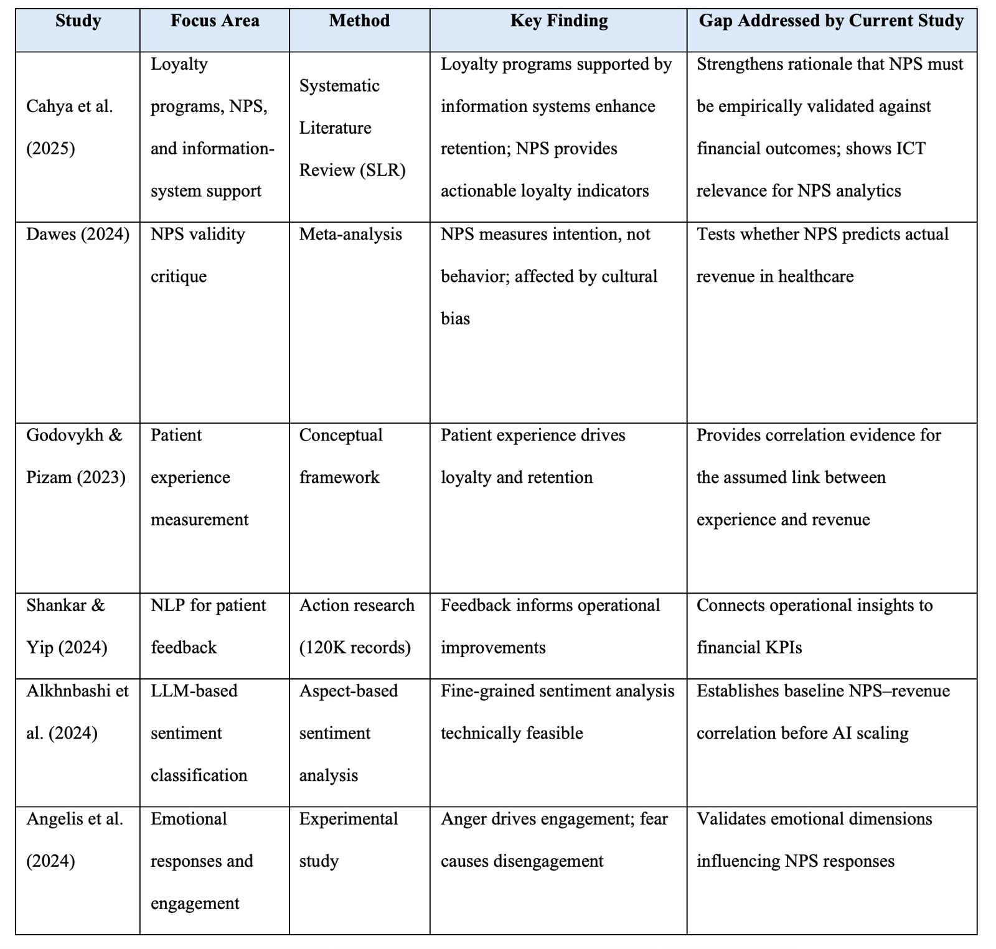

Note. Summary of key studies on patient experience and NPS metrics demonstrating operational or technical advancements yet lacking quantitative validation of sentiment-to-revenue relationships, the core focus addressed by this research.

# Identified Knowledge Gap and Research Contribution

Three converging gaps define this study's contribution, each representing a failure to validate assumptions that underpin current healthcare management practice:

1. **Metric Validation Gap:** NPS guides resource allocation despite never being empirically tested as a predictor of clinic-level financial performance (Dawes, 2024).
2. **Business Intelligence Gap:** Patient feedback analytics inform operational improvements (Shankar & Yip, 2024) and sentiment analysis proves technically feasible (Alkhnbashi et al., 2024), yet neither connects to measurable financial outcomes.
3. **ICT Foundation Gap:** AI sentiment systems (Alkhnbashi et al., 2024; Xiao et al., 2022) presume sentiment-to-performance correlations that remain statistically unverified, risking investment in systems optimizing wrong outcomes.

These three gaps are mutually reinforcing: reliance on unvalidated metrics (Gap 1) will continue to trigger operational fixes (Gap 2), which in turn will motivate AI system development (Gap 3), yet all three will remain unsupported without empirical evidence. This study will disrupt that cycle by generating the quantitative validation required across these domains. Clinics will no longer depend on assumed ROI; instead, this research will establish an evidence-based foundation through a longitudinal correlation analysis of 27,000 patient feedback records collected over 36 months from a multi-site healthcare provider.

*Figure 2 – Conceptual Model of the Relationship Between Patient Experience, NPS, and Revenue Growth.*

# **Methodology and Methods**

# Research Design and Philosophical Orientation

This research will adopt a quantitative correlational design under a pragmatic–positivist paradigm (Morgan, 2014). The aim is to test whether Net Promoter Score (NPS) statistically correlates with revenue growth in healthcare clinics. The design focuses on what works to generate actionable knowledge, combining business intelligence with empirical validation.

Quantitative analysis is justified because the research questions are relational rather than exploratory. It allows statistical testing of two hypotheses:

* H0: No significant correlation exists between NPS and revenue.
* H1: NPS is positively correlated with revenue.

The pragmatic stance recognizes that understanding this link is essential before introducing advanced AI feedback systems, thus aligning with ICT research-and-development principles of incremental validation (Wohlin & Runeson, 2021).

# Data Sources and Sampling

The study uses secondary data from Pro-Corpo Estética, a healthcare group with multiple clinic branches across Brazil. The dataset contains approximately 27,000 aggregated NPS survey responses collected between 2022–2025. Each record includes:

* Clinic ID / Store name
* Month & Year
* Average NPS score (0–10 scale)
* Monthly revenue (BRL)
* Number of responses per month

Because the population of available data is finite and fully accessible, no sampling technique is required. Instead, the full dataset is analyzed (a population study) to ensure statistical power and eliminate sampling bias (Cohen, 1988).

*Figure 3 –* *Existing NPS survey instrument used by Pro-Corpo Estética (2022-2025). This study will analyze aggregated responses from Question 1 (NPS score) and monthly revenue data, with Question 2 text comments available for future qualitative analysis.*

# Data Preparation

Data cleaning follows best practices in quantitative analytics (Field, 2018):

1. Duplicate removal based on timestamp and clinic ID.
2. Handling missing values:
   1. Missing NPS → excluded (non-imputable).
   2. Missing revenue → interpolated only for isolated gaps.
3. Outlier analysis: Revenue outliers >3 SD are flagged and compared against prior months for validation.
4. Transformation:
   1. NPS aggregated by month per clinic.
   2. Derived variables: Revenue Growth %, Lagged NPS (t-1, t-2) for temporal testing.
5. Integration: Merged on (*clinic_id + month + year*) ensuring chronological consistency.

All operations are executed in Python (Pandas, NumPy) with transparent logging for reproducibility.

# Analytical Procedures

To address **RQ1** (“To what extent is NPS correlated with monthly revenue growth?”), **Pearson and Spearman** correlation tests will be applied to quantify strength and direction.

For **RQ2** (“Can NPS trends predict short-term revenue changes?”), **simple linear regression** will assess predictive capacity using lagged variables.

Analysis workflow:

1. Descriptive statistics (mean, median, SD, min, max).
2. Visualization: scatterplots, heatmaps, line trends (Matplotlib/Streamlit).
3. Normality and assumption tests (Shapiro-Wilk, homoscedasticity).
4. Correlation & Regression Analysis.
5. Cross-validation: Run sub-analyses by clinic and year to test stability.
6. Exploratory Clustering Analysis: K-means clustering will be applied to identify natural groupings of clinics based on combined NPS–revenue profiles. This exploratory step will help determine whether clinics fall into meaningful behavioral categories—such as high-NPS/low-growth clinics, high-growth/low-NPS clinics, or consistently aligned high-performance clusters. These patterns will support interpretation of correlation and regression results by revealing whether the NPS–revenue relationship is uniform or varies across clinic types, strengthening the contextual understanding of financial and loyalty dynamics.

This structured process will triangulate statistical robustness through temporal, spatial, and methodological dimensions.

# Ethical Considerations

All data are anonymized and aggregated at the clinic-month level, removing personally identifiable information.

* Informed Institutional Consent: Pro-Corpo authorized academic use through a signed approval letter.
* Legal Compliance: Adheres to the Australian Privacy Act (1988), GDPR, and Brazil’s LGPD (Lei Geral de Proteção de Dados).
* Data Storage: Encrypted and accessed only via password-protected drives.
* Researcher Reflexivity: As a former collaborator, I will maintain objectivity by documenting analysis steps and separating personal insights from interpretation.

Ethical reflection shaped the methodology by limiting the study to anonymized, quantitative data, preventing exposure of sensitive health or identity information.

# Reliability, Validity and Limitations

* Reliability: Automated processing (Python scripts) ensures repeatable results.
* Construct Validity: NPS and revenue are directly measurable business metrics representing patient loyalty and financial performance.
* Internal Validity: Although correlation does not imply causation, temporal lags help infer potential directionality.
* External Validity: Findings are generalizable to similar healthcare service models but not beyond service-based industries.
* Limitations:
  + Restricted to one organization (Pro-Corpo).
  + Omitted qualitative feedback (text) that could contextualize numeric trends.
  + Confounding variables (seasonality, marketing campaigns) may influence outcomes.

Nevertheless, these limitations are mitigated through transparency, full-population analysis, and triangulation across time and location.

# Software Design Flow (ICT Framework Overview)

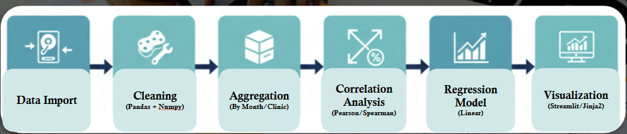

*Figure 4 – Data Analytics Workflow for NPS–Revenue Correlation Study*

This ICT pipeline will reflect evidence-based system design - a foundational principle of software engineering research (Wohlin et al., 2012).

# **Conclusion**

This research proposal will establish a systematic framework to investigate whether Net Promoter Score (NPS) serves as a valid predictor of revenue performance in healthcare clinics. The study addresses a critical gap in healthcare business intelligence: while NPS is widely adopted to measure patient loyalty, its correlation with financial outcomes remains empirically unvalidated. Two research questions guide the inquiry: (1) To what extent is NPS correlated with clinic-level revenue? and (2) Can NPS trends predict short-term financial fluctuations?

To answer these questions, the study employs a quantitative correlational design situated within a pragmatic-positivist paradigm, analyzing three years of longitudinal data (27,000 records) from Pro-Corpo Estética's multi-site healthcare network. The methodology will integrate descriptive statistics, Pearson and Spearman correlation analyses, and regression modeling with temporal lag variables, triangulated across time periods, clinic locations, and statistical approaches to ensure robustness. By establishing empirical evidence, or lack thereof, regarding the NPS-revenue relationship, this research will inform both managerial practice (validating or challenging current performance measurement systems) and academic research (providing a quantitative foundation for future AI-enhanced sentiment analysis in healthcare). The 12-week timeline ensures systematic execution from data preparation through statistical validation, with findings positioned to guide evidence-based healthcare management and responsible ICT innovation aligned with Torrens University's "Here for Good" ethos.

# Expected Contributions and Implications

Depending on statistical outcomes, this research will produce one of three strategic insights:

1. **Strong correlation (r > 0.70, p < 0.05**): Validates NPS as a strategic KPI, confirming simpler tracking systems suffice without AI enhancement.
2. **Moderate correlation (0.30 < r < 0.70, p < 0.05):** Indicates NPS provides partial insight, justifying investment in AI-enhanced sentiment analysis that captures richer feedback dimensions.
3. **Weak/no correlation (r < 0.30 or p > 0.05):** Challenges NPS validity in healthcare, redirecting investment toward NLP-based alternatives that capture nuanced emotional and experiential factors.

Regardless of outcome, this study advances evidence-based healthcare management by replacing assumption with empirical validation, enabling managers to make informed decisions about patient feedback systems while providing researchers with a quantitative foundation for AI-enhanced sentiment analytics.

The proposed 12-week timeline (Section 6) sequences these tasks systematically, from literature refinement and ethics clearance through data preparation, statistical analysis, and dissemination, ensuring reproducible execution aligned with ICT R&D best practices.

*Figure 5 – Prototype Dashboard for NPS and Revenue Monitoring (Concept for Future Work)*

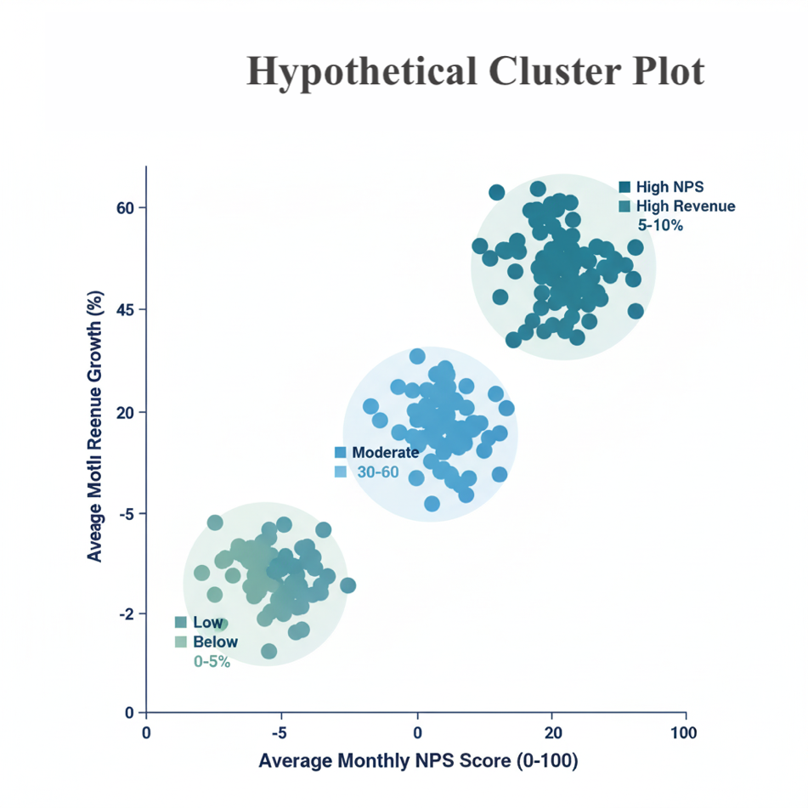

*Figure 6 – Cluster Plot showing potential grouping of clinics by NPS and revenue.*

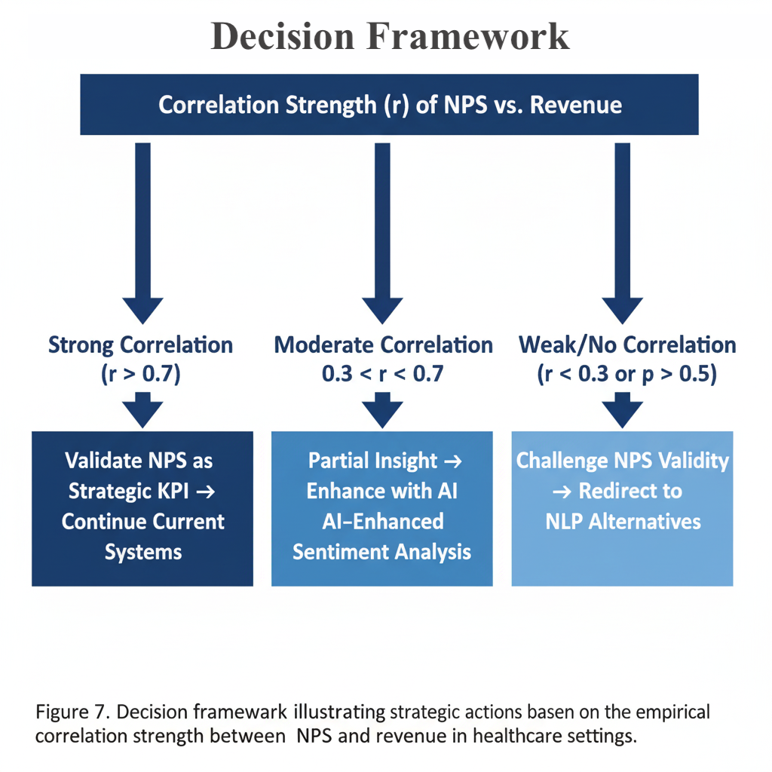

*Figure 7 – Decision Framework Based on Correlation Strength*

# **Proposed Timeline**

The proposed study will be conducted over a twelve-week period, reflecting a structured and iterative approach to quantitative research. The timeline follows a logical flow, beginning with conceptual refinement and ethical compliance, moving into data preparation and statistical analysis, and concluding with synthesis, validation, and dissemination. Each phase is intentionally sequenced to ensure the study progresses from theoretical grounding to empirical results while maintaining data integrity and ethical governance.

*Table 2 – Timeline in details with Phase/Task and Description*

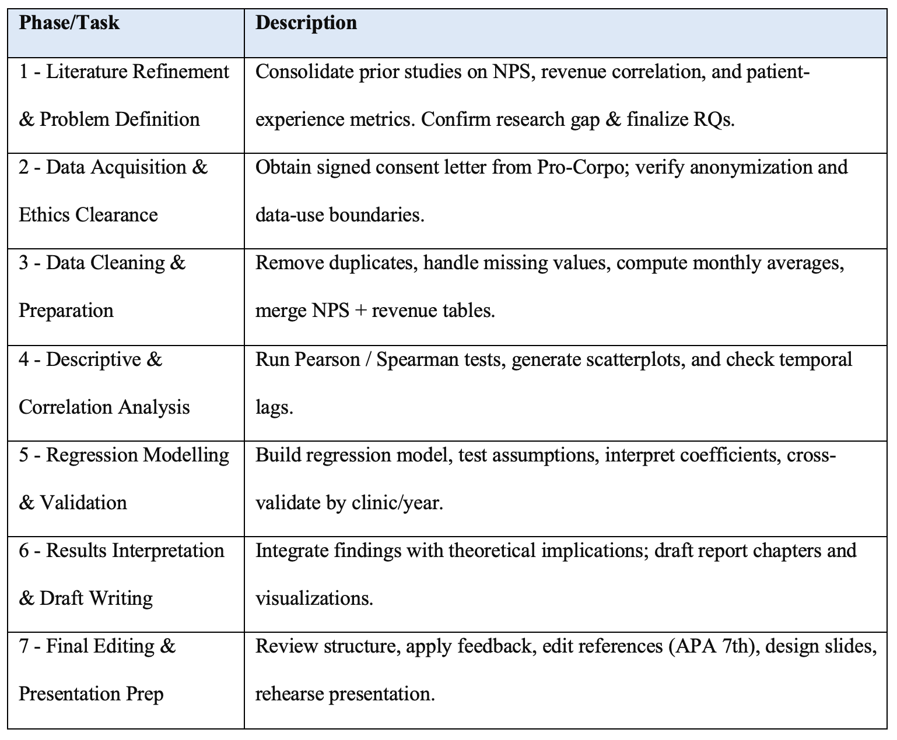

Post-Study Dissemination (Beyond Week 12): Following completion of the 12-week research cycle, findings will undergo extended validation and dissemination through journal publication (targeting *International Journal of Market Research* or *Journal of Healthcare Management*) and conference presentations. This extended phase (estimated 20-28 additional weeks) will involve manuscript preparation, peer review, and knowledge translation to both academic and practitioner audiences, ensuring research impact beyond the immediate assessment period.

This schedule ensures that analytical tasks are interleaved with reflection and validation, minimizing risks of data misinterpretation and ensuring that findings are actionable and reproducible. By Week 12, both the written report and the presentation materials will be complete, demonstrating a clear, ethical, and technically sound workflow from research conception to dissemination.

*Figure 7 – Project timeline showing overlapping phases throughout the 12-week research cycle.*

# **Appendices**

# Appendix A – Company Consent Letter

Signed authorization from Pro-Corpo Estética granting permission to use anonymized data for academic purposes.

# Appendix B – Data Preparation Code Excerpt

Snippet of Python workflow showing cleaning and correlation analysis.

*Figure 7 – Python workflow for data integration and transformation using Pandas. This reproducible pipeline ensures data quality and enables temporal analysis through lagged variables.*

# Appendix C – Ethics Statement

This research will comply with the following ethical and legal frameworks:

**Institutional Approval:**

* Formal written consent obtained from Pro-Corpo Estética (see Appendix A)
* Approval for academic use of anonymized, aggregated data

**Data Protection Compliance:**

* Australian Privacy Act 1988 (data storage in Australia)
* Brazil Lei Geral de Proteção de Dados (LGPD) - data origin compliance
* GDPR principles (data minimization, purpose limitation, storage limitation)

**Anonymization Protocol:**

* All data aggregated at clinic-month level
* No personally identifiable information (PII) retained
* Individual patient records never accessed by researcher

**Researcher Reflexivity Statement:** As a former internal collaborator with Pro-Corpo, I acknowledge potential confirmation bias (desire for NPS to correlate with revenue to validate systems I helped implement). Mitigation strategies include:

* Pre-registered analysis plan documented before data access
* Objective statistical thresholds (α = 0.05) applied consistently
* External review of methodological choices by academic supervisor
* Commitment to publishing findings regardless of direction (positive, negative, or null results)

**Data Security:**

* Encrypted storage on password-protected drives
* Access restricted to researcher and academic supervisor
* Data retention limited to assessment completion + 5 years (institutional policy)
* Secure deletion protocol post-retention period

*.*

End of Appendix Section

**Statement of Acknowledgment**

I acknowledge that I have used the following AI tool(s) in the creation of this report:

* + OpenAI ChatGPT (GPT-5): Used to assist with outlining, refining structure, improving clarity of academic language, and supporting APA 7th referencing conventions.

I confirm that the use of the AI tool has been in accordance with the Torrens University Australia Academic Integrity Policy and TUA, Think and MDS’s Position Paper on the Use of AI. I confirm that the final output is authored by me and represents my own critical thinking, analysis, and synthesis of sources. I take full responsibility for the final content of this report.

# **References**

Alkhnbashi, O. S., Mohammad, R., & Hammoudeh, M. (2024). *Aspect-based sentiment analysis of patient feedback using large language models.* Big Data and Cognitive Computing, 8(12). https://doi.org/10.3390/bdcc8120167

Angelis, J. N., Murthy, R. S., Beaulieu, T., & Miller, J. C. (2024). *Better angry than afraid: the case of post data breach emotions on customer engagement.* IEEE Transactions on Engineering Management, 71, 2593–2605. https://doi.org/10.1109/TEM.2022.3189599

Bryman, A. (2016). *Social research methods* (5th ed.). Oxford University Press.

Cahya, V. N. C., Setyanto, R., & Paradise, P. (2025). *Analysis of the effectiveness of loyalty membership programs in increasing customer retention using net promoter score (NPS) with information system support*. Eduvest-Journal of Universal Studies, 5(9), 10974-10983.

Chen, E. (2023). *Growth product manager’s handbook.* O’Reilly Media.

Cohen, J. (1988). *Statistical power analysis for the behavioral sciences* (2nd ed.). Routledge.

Creswell, J. W., & Plano Clark, V. L. (2023). *Designing and conducting mixed methods research* (4th ed.). SAGE Publications.

Dawes, J. G. (2024). *The net promoter score: What should managers know? International Journal of Market Research*, 66(2–3), 182–198. https://doi.org/10.1177/14707853231195003

Dawes, J. G. (2024). N*et promoter and revenue growth: An examination across three industries.* Australasian Marketing Journal, 32(1), 4-18.

Field, A. (2018). *Discovering statistics using IBM SPSS Statistics* (5th ed.). SAGE Publications.

Godovykh, M., & Pizam, A. (2023). *Measuring patient experience in healthcare.* International Journal of Hospitality Management, 112, 103405. https://doi.org/10.1016/j.ijhm.2022.103405

Mar, J., & Armaly, P. (2023). *Mastering customer success.* O’Reilly Media.

Morgan, D. L. (2014). *Pragmatism as a paradigm for social research*. Qualitative Inquiry, 20(8), 1045–1053. https://doi.org/10.1177/1077800413513733

Pallant, J. (2020). *SPSS survival manual* (7th ed.). Routledge.

Polonsky, M. J., & Waller, D. S. (2019). Quantitative data analysis. *In Designing and managing a research project* (4th ed., pp. 222-254). SAGE Publications. https://doi.org/10.4135/9781544316499

Shankar, R., & Yip, A. (2024). *Transforming patient feedback into actionable insights through natural language processing: A knowledge discovery and action research study.* JMIR Formative Research. https://doi.org/10.2196/69699

Wohlin, C., Runeson, P., Höst, M., Ohlsson, M. C., Regnell, B., & Wesslén, A. (2012). *Experimentation in software engineering*. Springer.

Wohlin, C., & Runeson, P. (2021). Guiding the selection of research methodology in industry–academia collaboration in software engineering. *Information and Software Technology*, 140, 106678. https://doi.org/10.1016/j.infsof.2021.106678

Xiao, Y., Li, C., Thürer, M., Liu, Y., & Qu, T. (2022). *Towards lean automation: Fine-grained sentiment analysis for customer value identification.* Computers and Industrial Engineering, 169. https://doi.org/10.1016/j.cie.2022.108186